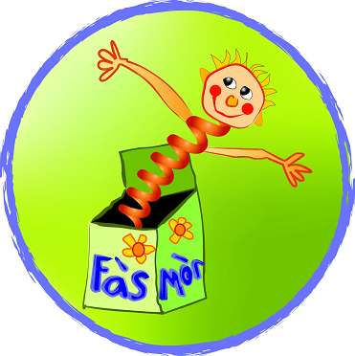

Tha sinn uile ag ionnsachadh mu dheidhinn ‘Ramadan’ am mìos seo ann am Fàs Mòr (clann is luchd-obrach!) agus fhuair sinn a-mach gum bi iad a’ togail airgid fad mìos airson dhaoine aig a bheil duilgheadas.
Rinn a’ chlann crogain agus thàinig sinn uile gu co-dhùnadh airgid a thogail airson na daoine mi-fhortanach ann am Pakistan an dràsta.

We are all learning about Ramadan this month in Fàs Mòr (children and staff!) and have found out that during the month of Ramadan money is raised for people less fortunate.
The children have made charity jars and we have all decided that we would like to raise money for the people of Pakistan who are suffering right now.


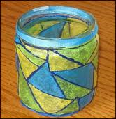

Ma tha clann, pàrant no duine sam bith airson airgid a chur a-steach dhan crogain a rinn a’ chlann tha iad taobh a staigh Fàs Mòr. Thig a-steach is can haidh ruinn!
If children, parents or anybody else would like to put any money in the children’s jars then they are within Fàs Mòr. Please come by and say hello!

Tha sinn ag ionnsachadh mu dheidhinn Ramadan am mìos seo agus fhuair sinn a mach gum bi iad a’ togail airgid airson dhaoine aig a bheil duilgheadas tron a’ mhios.
Rinn sinn crogan còmhla ris a’ chloinn agus tha sinn ag iarraidh airgid a thogail airson na daoine à Pakistan.

We are learning about Ramadan and have found out that during the month of Ramadan money is raised for people less fortunate.
We have made charity jars with the children and would like to raise money for the people of Pakistan.

Ma tha a’ chlann is na pàrantan airson airgid a chur a-steach dhan crogain tha iad taobh a staigh Fàs Mòr.
If any children and parents would like to put any money in the jars then they are within Fàs Mòr.

Tapadh leibh

